**Name (netid):** Johnathon Small (jssmall3)

**CS 445 - Project 4: Image Based Lighting**

Complete the claimed points and sections below.

**Total Points Claimed [120] / 210**

**Core**

1. Recovering HDR maps
   1. Data collection [20] / 20
   2. Naive HDR merging [10] / 10
   3. Weighted HDR merging [15] / 15
   4. Calibrated HDR merging [15] / 15
   5. Additional HDR questions [10] / 10
2. Panoramic transformations [10] / 10
3. Rendering synthetic objects [30] / 30
4. Quality of results / report [10] / 10

**B&W**

1. Additional results [0] / 20
2. Other transformations [0] / 20
3. Photographer & Tripod removal [0] / 25
4. Local tone-mapping operator [0] / 25

**1. Recovering HDR maps**

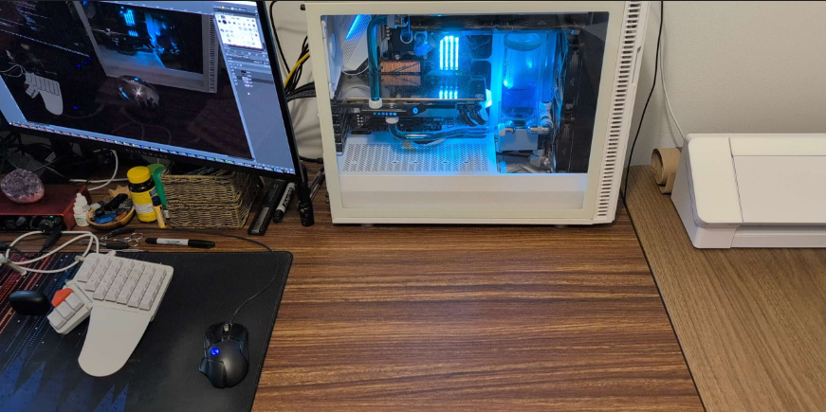

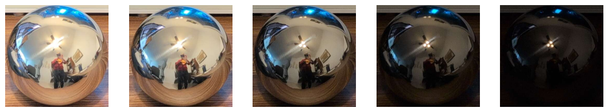

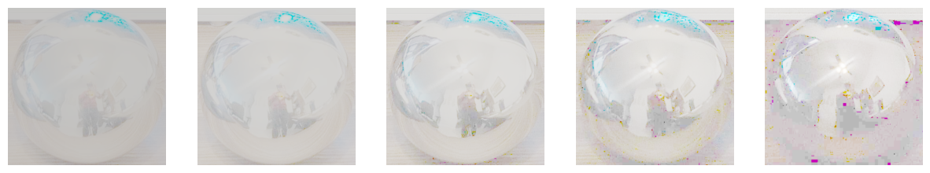

**[A/B]** The images above show the full, empty scene (top), the original mirror ball photographs (middle), and the output of the naïve log irradiance images (bottom). I chose this particular scene because I was curious about the reproduction of the tinted light sources coming from the computer. The log irradiance images are very washed out and suffer from artifacting as the images get darker. These magenta artifacts are likely the result of a zero response from the green sensor in the camera, causing the red and blue channels to scale while leaving the green channel untouched.



**[C]** The images above show the log irradiance images produced by the weighted method. They are largely similar to the naïve method given that both methods use the same underlying calculation. The biggest differences are found in very dark and very bright regions, such as the ceiling fan light. The naïve method treats every exposure equally, so saturated and near-black pixels still contribute, despite being out of the sensor’s range at that exposure. The weighting gives little weight to these unreliable pixels, instead emphasizing mid-range intensities in each exposure, which leads to brighter highlights and darker blacks (compared to the average image). However, both approaches still create approximately the same range because they operate on the raw pixel intensities and linear scaling.

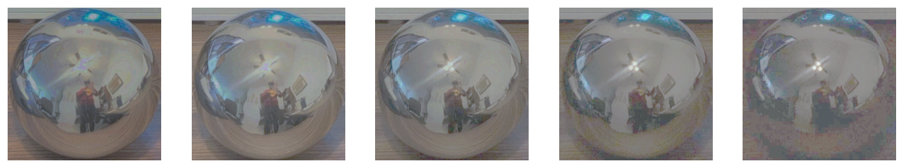

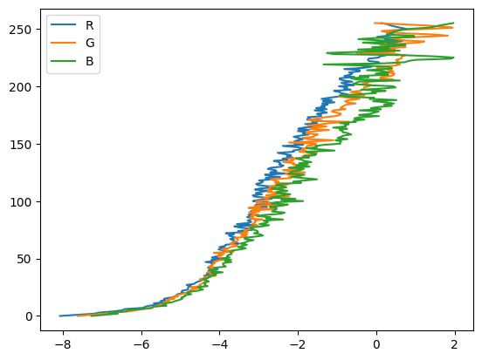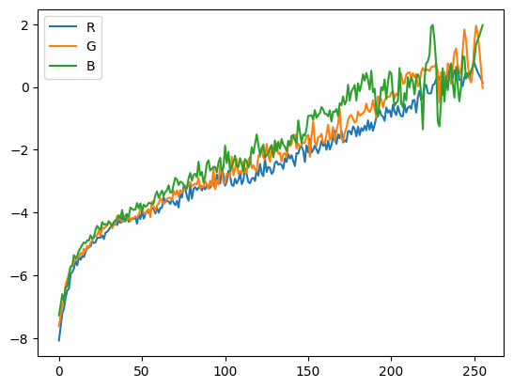

**[D]** The images above show the log irradiance images of the calibrated method (top), along with the graphs comparing g vs intensity (left) and intensity vs g (right). These graphs show an expected relationship between the irradiances and the image intensities, with greater response from higher intensities and an emphasized response midtones (which contain more valuable information to a human viewer); dark tones are compressed, with changes in irradiance producing smaller changes in intensity, while highlights saturate the sensor, causing the response to flatten out as we approach maximum intensity. High intensity data is less certain, likely because we have few unsaturated pixels near those maximum values, giving the solver less data to accurately constrain g.

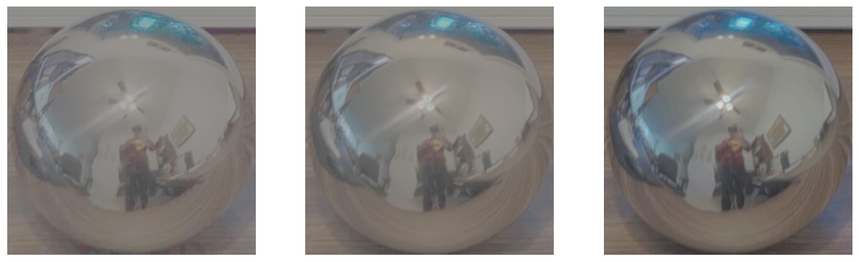

|  |  |  |
| --- | --- | --- |
| Method | Log Range | Average RMS Error |
| Naïve | 7.897 | .634 |
| Weighted | 7.718 | .637 |
| Calibrated | 13.027 | .416 |

**[B-D]** The images above compared the combined outputs of the three methods (from left to right: naïve, weighted, calibrated). The table above describes the log range of the images (effectively indicating the amount of dynamic range we recovered) and the RMS error (comparing the constituent images to the combined image).

We can observe the aforementioned increase in highlight intensities clearly as we step through the images by looking at the ceiling fan lights. In the naïve image, the light is blown out and the specular highlights are close in intensity. In the weighted image, we recover more detail from the lights themselves, with less bloom around the three bulbs. Finally, the calibrated image best reflects the difference in intensity between the bulbs and the highlights. This is no surprise given the much greater dynamic range of this image (as seen in the table above).

**[E]**

1. For a very bright scene point, will the naive method tend to over-estimate the true brightness, or under-estimate? Why?

The naïve method will underestimate the true brightness because it treats all measurements as true measurements. When the camera captures a 255 intensity for a pixel, the method considers this a true 255 rather than an intensity somewhere above the measurable range. This clipping lowers the brightness of these regions.

1. Why does the weighting method result in a higher dynamic range than the naive method?

The weighting method suppresses the unreliable, clipped measurements that contribute to the underestimation in question #1. By giving pixels lower weight the further they are from the median response, this method emphasizes mid-range intensities where the data is more reliable and linear. Interestingly, we still see the same log range between the naïve and weighted methods. This is because, while we changed how much each exposure contributes, we didn’t change the scale the values exist on. The irradiances are still averaged within the same 8-bit intensity domain.

1. Why does the calibration method result in a higher dynamic range than the weighting method?

While the weighted method assumes a linear relationship between intensity and exposure (a false assumption), the calibration method actually estimates the true (inverse) response of the camera, recovering true relative radiance from the camera’s compressed outputs. Because the function translates intensity values from the images into logarithmic space, then into linear irradiance values, we can see actual physical differences in light intensity in a much greater range.

1. Why does the calibration method result in higher consistency, compared to the weighting method?

The calibration method’s higher consistency comes from its global model. The calibration/gsolve step creates a single camera response curve that is applied to all input pixel intensities, resulting in one physically consistent transformation. The weighted method averages pixel values locally without any global function, so the effects of noise or intensity errors are differentially applied to different regions.

**2. Panoramic transformations**

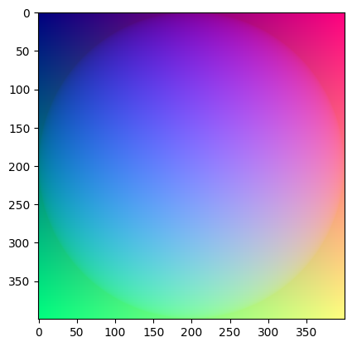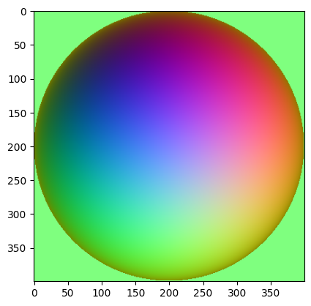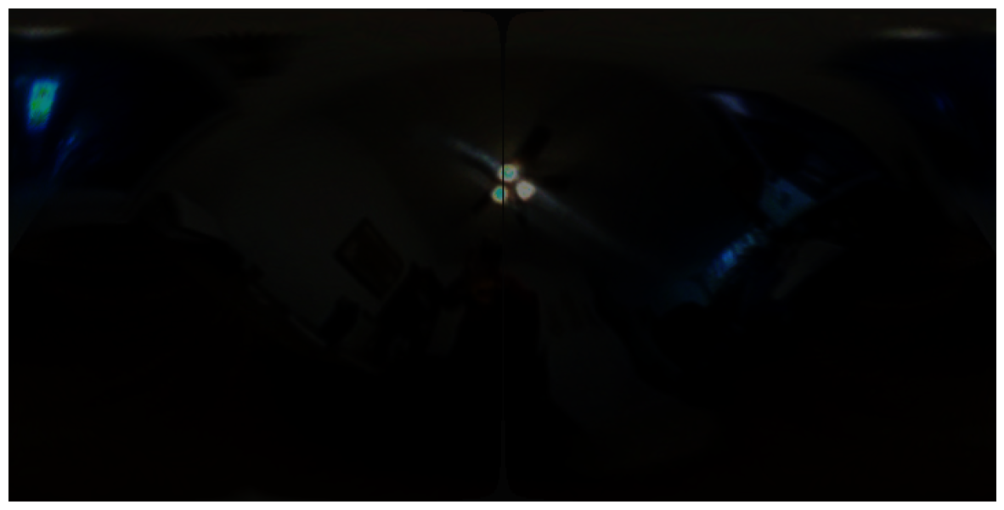

The images above show the normal vectors (top left), reflectance vectors (top right), and equirectangular image (bottom). These vectors in three dimensions are visualized in the red, green, and blue channels of the images, showing the surface normals of the sphere as well as the direction of light reflectance based relative to the camera. The equirectangular image, created via the reflectance map, represents a lighting map in any given direction, letting us recreate the lighting from the scene. The image is quite dark because of our linear mapping of HDR tones into the image; the ceiling fan lights are many times brighter than the diffuse reflections off of the walls, and even several times brighter than the monitor and RGB lighting, so they dominant the image. To compensate for this, I set the strength of the environment light map to 100 in blender.

**3. Rendering synthetic objects**

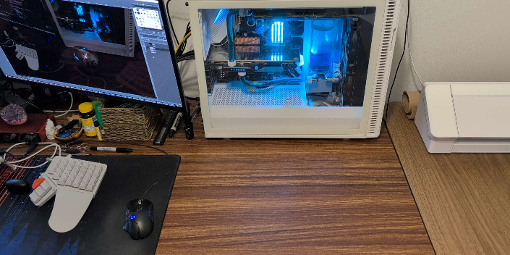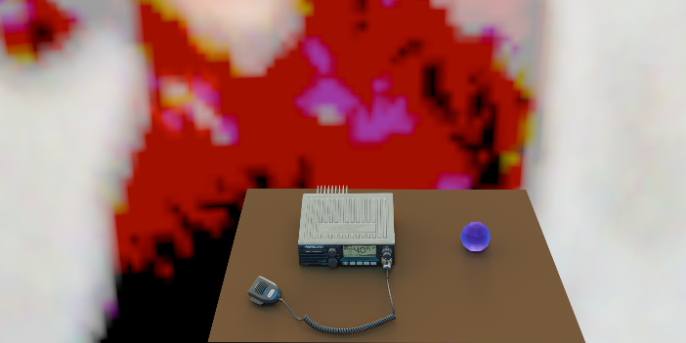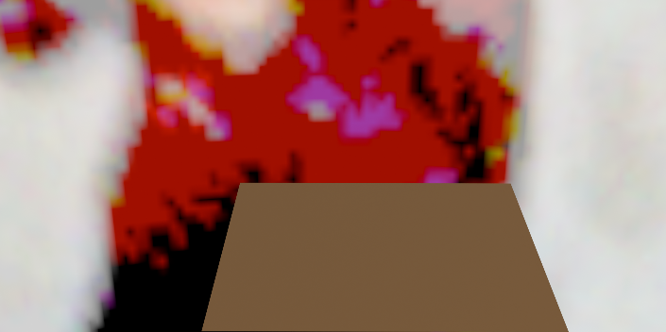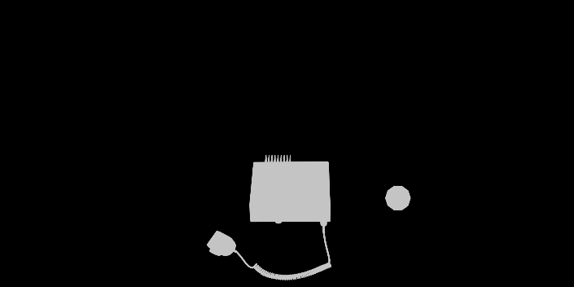

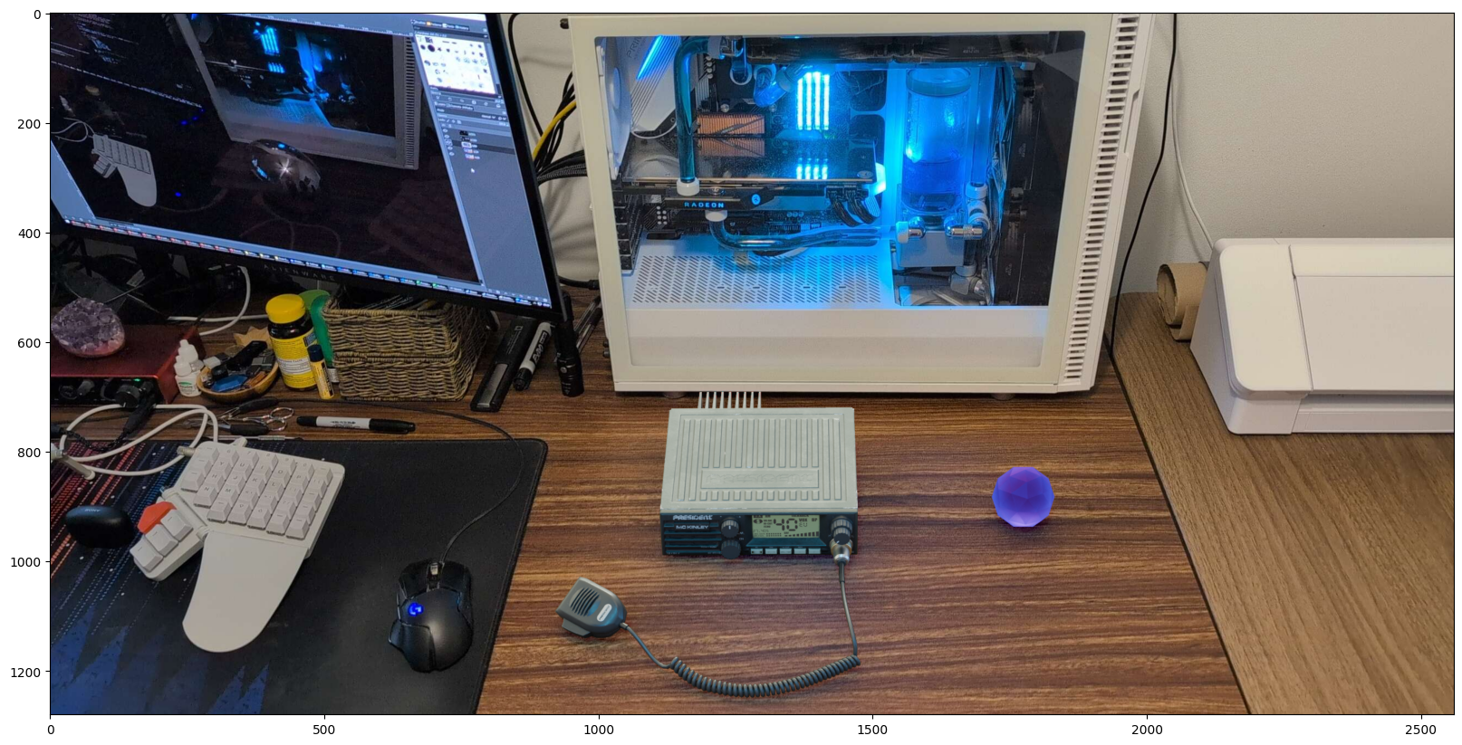

The images above show the components for and result of a composited render, including the native scene (top left), rendered objects (top right), the empty scene (middle left), a mask of the objects (middle right), and finally the composited image (bottom). The image features a free radio asset obtained from Turbosquid (with provided textures and materials) as well as a icosahedron with a purple-tinted glass material applied.

Note the blue specular highlights on the radio’s microphone handset; the shiny material of the handset reflects the blue RGB lighting from the computer, captured by the environment map. We can see a similar highlight from the overhead light on the straight section of cable. The image is not entirely perfect, and the environment lighting would likely benefit from some further tuning to better match the source image. Despite the material of the icosahedron, there is no meaningful purple cast in its shadow as we might expect from a strong overhead light illuminating glass, either from the brightness of the lightmap or too great of an opacity in the material properties.

**4. Quality of results / report**

Nothing extra to include (scoring: 0=poor 5=average 10=great).

**5. Additional results (B&W)**

Not completed.

**6. Other transformations (B&W)**

Not completed.

**7. Photographer and tripod removal (B&W)**

Not completed.

**8. Local tone-mapping operator (B&W)**

Not completed.

**Acknowledgments / Attribution**

* The radio and handset model was published by GameReady LODs for free for editorial uses: <https://www.turbosquid.com/3d-models/3d-radiostation-mckinley-gameready-lods-1963887>
* All images taken by me.